COMMON COURSE ASSIGNMENT FORMAT

Assignment Information

Particular | Details
Department: | COMPUTER SCIENCE AND ENGINEERING AI/ML
Programme: | B Tech
Course Code & Course Name | CSA0504 - DATABASE MANAGEMENT SYSTEMS
Academic Year / Batch | 2026-2027
Faculty Name | Dr. K. SARAVANAN
Assignment Title | An Online Examination Database System using Student(Student_ID, Student_Name, Program_ID, Semester), Course(Course_ID, Course_Code, Course_Name, Credits), Exam(Exam_ID, Course_ID, Exam_Date, Maximum_Mark), Question(Question_ID, Exam_ID, Question_Text, Marks), Submission(Submission_ID, Exam_ID, Student_ID, Start_Time, Submit_Time, Status), Result(Result_ID, Exam_ID, Student_ID, Total_Mark, Grade). Develop the ER model and relational schemas. Identify functional dependencies and normalize the relations. Design indexes for Student_ID and Exam_ID. Write SQL queries for course-wise results and top performers. Explain transaction management during result submission. Discuss concurrency and recovery requirements.
Date of Issue | 20-08-2026
Date of Submission | 03-09-2026
Maximum Marks | 100
Course Outcome(s) – CO | CO1: Analyze DBMS architecture, different data models, schema types, and design ER/EER diagrams, relational schemas for case-based scenarios by identifying entities and relationships. (BL1, BL2)  CO3: Analyze relational databases using functional dependencies, normalization (1NF to 5NF), and key constraints to identify redundancy and ensure data integrity. (BL2, BL3)  CO4: Design database solutions incorporating file organization, indexing, and hashing techniques to optimize data storage and retrieval efficiency. (BL3, BL4)  CO5: Implement database operations using query processing, optimization, and transaction management to ensure consistency and reliability. (BL3, BL4)
Bloom's Taxonomy Level | L4 – Analyze, L6 – Create, L3 – Apply
SDG Mapping (SDG 1-17) | SDG 4 – Quality Education and  SDG 9 – Industry, Innovation and Infrastructure
Industry / Societal Relevance | The Online Examination Database System is highly relevant to educational institutions, universities, certification bodies, and e-learning platforms for managing students, courses, examinations, submissions, and results efficiently. It demonstrates industry practices in database design, normalization, indexing, SQL query processing, transaction management, concurrency control, and recovery. The system reduces manual work, improves data accuracy and integrity, enables faster result retrieval, and supports secure and reliable examination processes. From a societal perspective, it promotes digital education, transparent evaluation, accessibility, and efficient academic administration.

Assignment Problem / Challenge

An Online Examination Database System using Student(Student_ID, Student_Name, Program_ID, Semester), Course(Course_ID, Course_Code, Course_Name, Credits), Exam(Exam_ID, Course_ID, Exam_Date, Maximum_Mark), Question(Question_ID, Exam_ID, Question_Text, Marks), Submission(Submission_ID, Exam_ID, Student_ID, Start_Time, Submit_Time, Status), Result(Result_ID, Exam_ID, Student_ID, Total_Mark, Grade). Develop the ER model and relational schemas. Identify functional dependencies and normalize the relations. Design indexes for Student_ID and Exam_ID. Write SQL queries for course-wise results and top performers. Explain transaction management during result submission. Discuss concurrency and recovery requirements

Realistic engineering/scientific/computing problem, case, challenge or design requirement related to the Course Outcome.
- The proposed Online Examination Database System is designed to manage the complete examination process of an educational institution through a centralized and reliable database. The system must efficiently store and manage student details, courses, examinations, questions, submissions, and results while maintaining data accuracy and integrity.
- The major challenge is to design a normalized relational database that minimizes redundancy and supports efficient data retrieval. Proper functional dependencies, primary keys, foreign keys, and normalization techniques must be applied to ensure consistency. Indexes on Student_ID and Exam_ID are required to improve the speed of searching and retrieving examination and result information.
- The system must also support SQL operations such as course-wise result analysis and identification of top-performing students. During result submission, transaction management must ensure that marks are stored correctly without partial or inconsistent updates. Since multiple students may submit examinations simultaneously, concurrency control is required to prevent conflicts. Recovery mechanisms must also be considered to protect examination and result data from system failures.
- Overall, the design demonstrates practical applications of ER modeling, relational database design, normalization, indexing, query processing, transaction management, concurrency control, and database recovery in a real-world educational environment.

C.Problem Statement

Problem / Case / Design Challenge:

[Faculty to provide the detailed assignment problem here.]
Problem / Case / Design Challenge:
Educational institutions require an efficient and reliable system to manage online examinations, student submissions, and examination results. Manual handling of such data can lead to redundancy, errors, slow retrieval, and difficulties in managing multiple submissions simultaneously.
The Online Examination Database System aims to design a structured database for managing students, courses, examinations, questions, submissions, and results. The system should apply R modeling, relational schemas, functional dependencies, normalization, indexing, SQL queries, transaction management, concurrency control, and recovery techniques to ensure efficient, accurate, and reliable examination data management.

D.requirements and Constraints
Students shall identify or be provided with relevant requirements and constraints. Examples include:
  - Functional requirements
  - Performance requirements
  - Technical constraints
  - Cost, Time
  - Resources
  - Safety
  - Reliability
  - Sustainability
  - Environmental and Ethical considerations
  - Standards/codes
  - User requirements
  - Manufacturability
  - Power/energy
  - Security/privacy

Only constraints relevant to the particular course/problem need to be considered.
Requirements
- Functional Requirements: The system should store and manage students, courses, exams, questions, submissions, and results.
- Performance Requirements: Student and examination records should be retrieved quickly using suitable indexes on Student_ID and Exam_ID.
- Reliability: The database should maintain accurate and consistent data during examination and result processing.
- Security and Privacy: Student details, examination data, and results should be protected from unauthorized access.
- User Requirements: Faculty should be able to manage examinations and results, while students should be able to submit exams and view their results.
- Transaction Management: Result submission should be completed correctly without partial or inconsistent updates.
- Concurrency: The system should handle multiple students submitting examinations at the same time without data conflicts.
Constraints
- Technical Constraints: The system must follow relational database principles and use appropriate keys, constraints, normalization, and indexing.
- Time Constraint: The database design and implementation must be completed within the assigned academic schedule.
- Resource Constraint: The system should use available database software and computing resources efficiently.
- Data Privacy Constraint: Access to student and examination information must be restricted to authorized users.
- Recovery Constraint: The database should support backup and recovery to prevent loss of examination and result data during failures.

E. Student Work

Problem Understanding and Formulation

Explain:

  - What is the problem?
  - What are the expected outcomes?
  - What information/data is available?
  - What assumptions are made?
- What constraints must be satisfied?

A. Student Work
1. Problem Understanding and Formulation
● What is the problem?
The problem is to develop an Online Examination Database System to manage student details, courses, examinations, questions, submissions, and results efficiently.
● What are the expected outcomes?
The expected outcome is a well-organized and normalized database that provides accurate result processing, fast data retrieval, course-wise results, and identification of top-performing students.
● What information/data is available?
The available data includes student details, course details, examination details, questions, submission records, marks, and grades.
● What assumptions are made?
It is assumed that every student, course, examination, question, submission, and result has a unique ID. Only authorized users can manage examination and result information.
● What constraints must be satisfied?
The system must maintain data integrity, security, reliability, and consistency. It should reduce redundancy through normalization, provide fast access using indexes, and handle simultaneous submissions using concurrency and transaction management.

A student answers 20 questions. Each correct answer carries 2 marks. The student answers 15 questions correctly. Calculate the total marks.
Calculation:
Total Marks = Correct Answers × Marks per Question
= 15 × 2
= 30 marks
Answer: 30 marks.

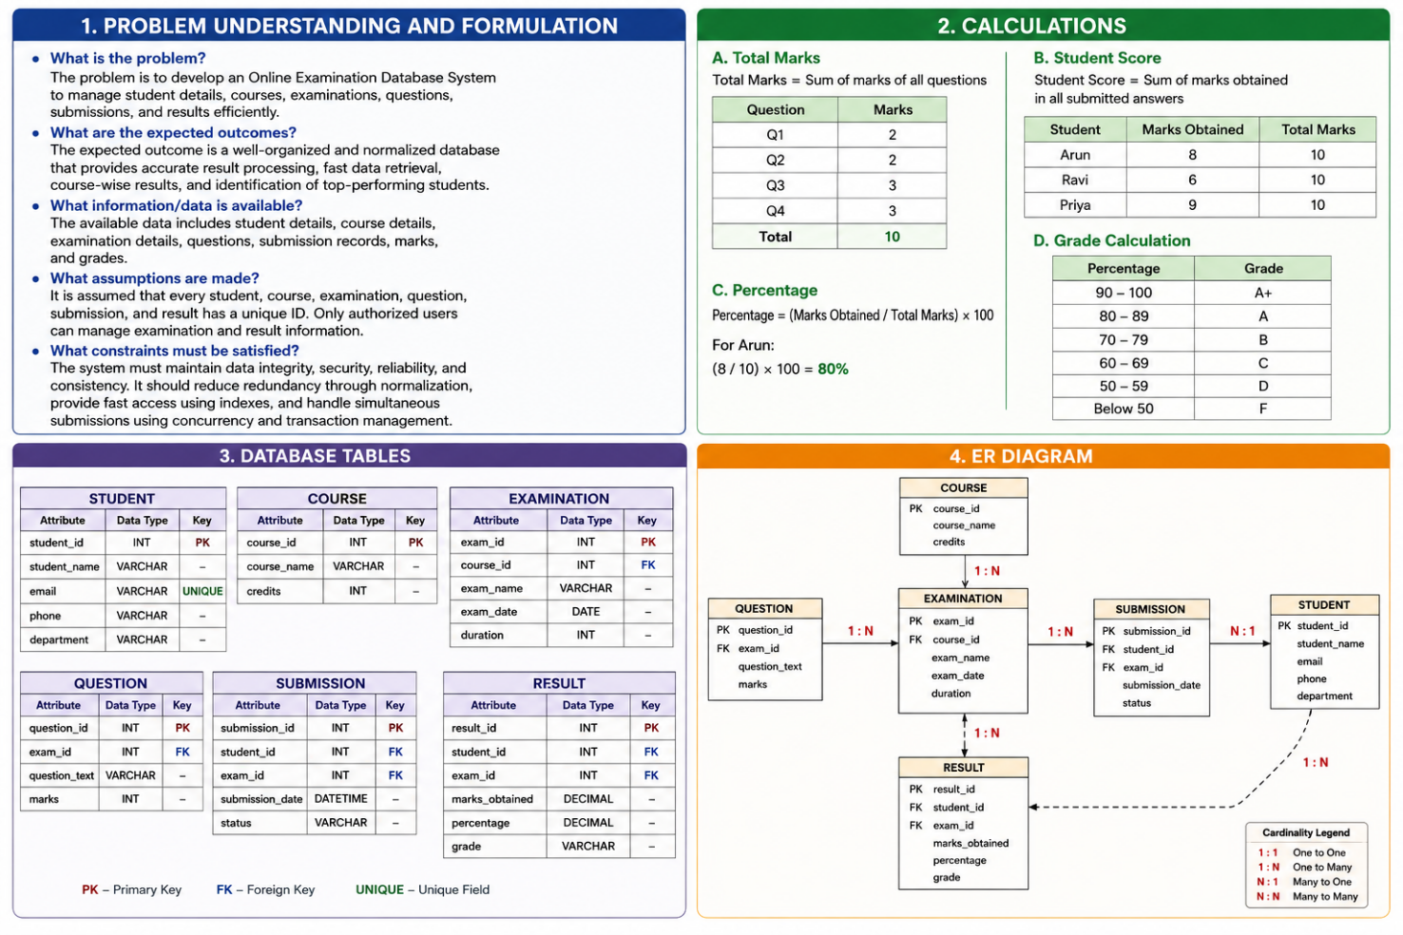

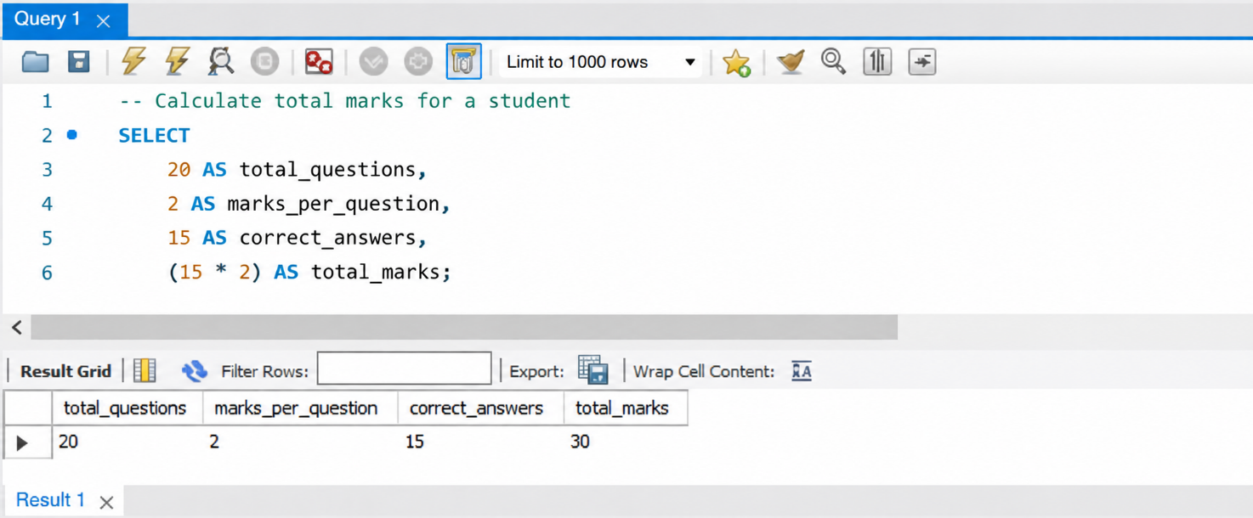

Application of Course Knowledge

Identify and apply the relevant:

  - Principles
  - Theories
  - Mathematical models
  - Algorithms
  - Engineering concepts
  - Scientific concepts
  - Design methodologies

Show necessary calculations, derivations or reasoning.

1. Application of Course Knowledge
The following DBMS principles and concepts are applied in the Online Examination Database System:
- ER Modeling: Identifies entities such as Student, Course, Exam, Question, Submission, and Result, along with their relationships.
- Relational Model: Converts the ER model into relational tables using primary keys and foreign keys.
- Functional Dependencies: Used to identify relationships between attributes and determine appropriate candidate keys.
- Normalization: Relations are normalized from 1NF to 3NF to reduce data redundancy and avoid insertion, deletion, and update anomalies.
- Indexing: Indexes are created on Student_ID and Exam_ID to improve the speed of searching and retrieving records.
- SQL Algorithms/Queries: SQL operations such as JOIN, GROUP BY, aggregate functions, and ORDER BY are used to generate course-wise results and identify top performers.
- Transaction Management: ACID properties are applied during result submission to maintain consistency and reliability.
- Concurrency Control: Database locking and transaction control concepts are used to handle multiple students submitting examinations simultaneously.
- Recovery: Commit, Rollback, and backup/recovery techniques are considered to protect data from system failures.
- Design Methodology: The system follows a structured approach of requirement analysis → ER modeling → relational schema design → normalization → indexing → SQL implementation → transaction and recovery design.

Suppose an exam has 50 questions, and each question carries 2 marks.
Maximum Marks = Number of Questions × Marks per Question
= 50 × 2
= 100 marks
If a student answers 42 questions correctly:
Student Score = Correct Answers × Marks per Question
= 42 × 2
= 84 marks
Percentage = (Marks Obtained / Maximum Marks) × 100
= (84 / 100) × 100
= 84%
Result: The student scored 84 marks (84%).

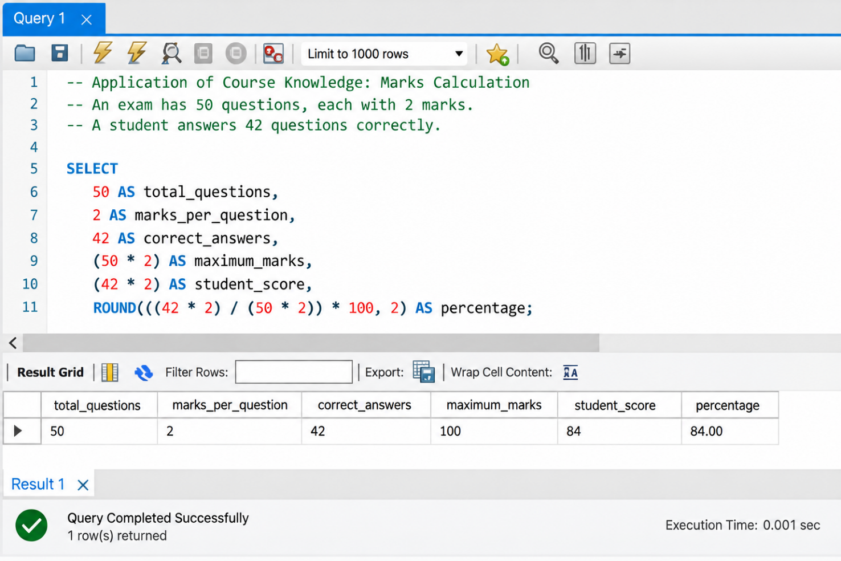

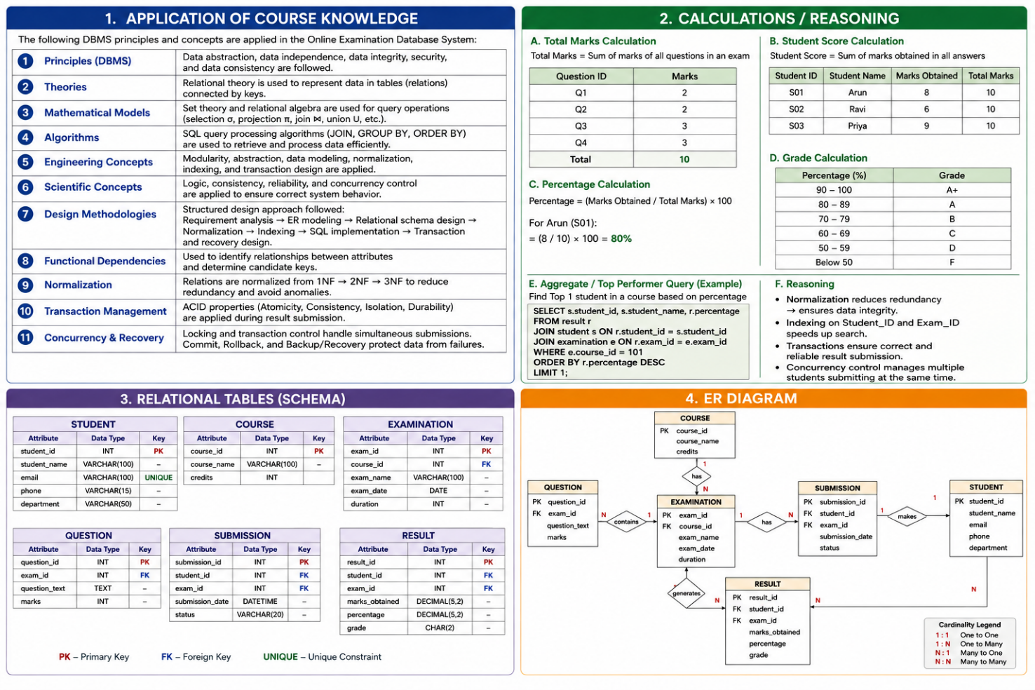

Solution / Design / Methodology

Develop the proposed solution. Depending upon the nature of the course, this may include:

  - Design
  - Algorithm
  - Model
  - Circuit
  - Architecture
  - Experiment
  - Process
  - Prototype
  - Simulation
  - Case analysis
  - Data analysis
  - Mathematical solution

Where appropriate, consider more than one possible solution.

1. Solution / Design / Methodology
The proposed solution is an Online Examination Database System that provides a structured and efficient way to manage examination-related information.
Proposed Design
- ER Model: The system consists of six main entities: Student, Course, Exam, Question, Submission, and Result.
- Relational Schema: Each entity is converted into a relational table with appropriate primary keys and foreign keys.
- Normalization: The tables are normalized up to 3NF to reduce redundancy and maintain data integrity.
- Indexing: Indexes are created on Student_ID and Exam_ID for faster data retrieval.
- SQL Processing: SQL queries using JOIN, GROUP BY, AVG, MAX, and ORDER BY are used for course-wise results and top-performer analysis.
- Transaction Processing: COMMIT and ROLLBACK are used during result submission to ensure consistent database updates.
- Concurrency and Recovery: Appropriate concurrency control and recovery techniques are considered to handle simultaneous submissions and system failures.
Methodology
Requirement Analysis → ER Model → Relational Schema → Functional Dependencies → Normalization → Indexing → SQL Queries → Transaction Management → Concurrency & Recovery → Final Database Design
Alternative Solution
A basic database without indexing and proper normalization could also store the examination data, but it may result in data redundancy, slower retrieval, and consistency problems. Therefore, the normalized and indexed relational database is selected as the more efficient and reliable solution.

Question: Calculate the average marks of 5 students.
Marks obtained: 80, 75, 90, 85, 70
Average = Total Marks ÷ Number of Students
= (80 + 75 + 90 + 85 + 70) ÷ 5
= 400 ÷ 5
= 80 marks
Result: The average mark is 80.
SQL Query Example:
SELECT AVG(Marks) AS Average_Marks
FROM Result;

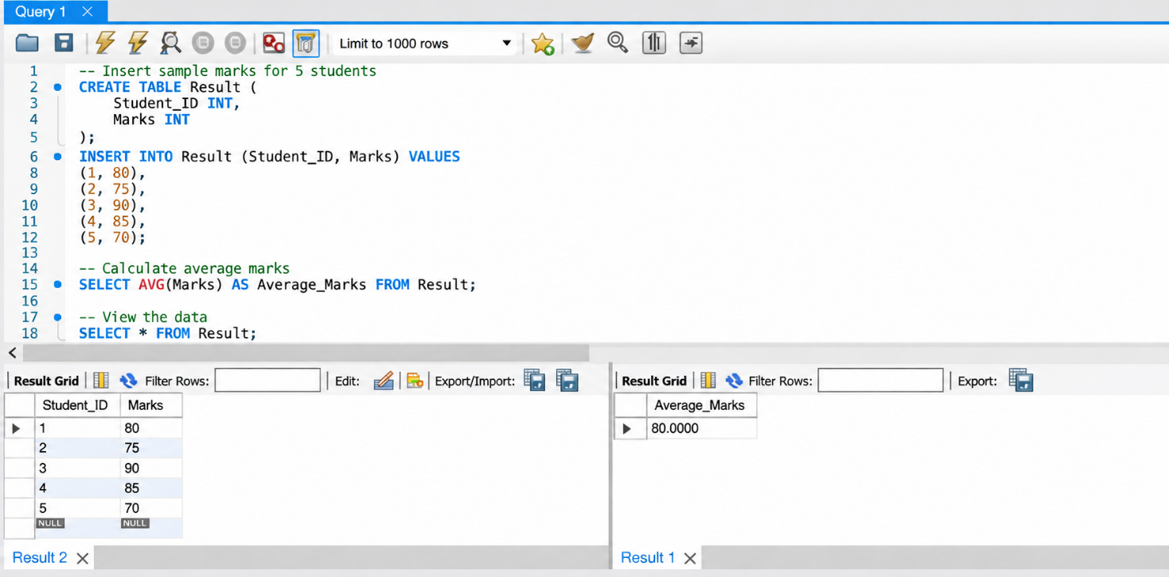

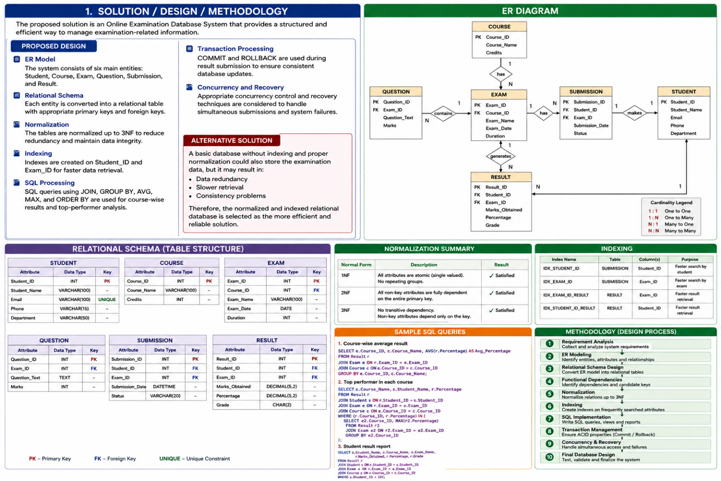

Use of Modern Tools

Use appropriate tools wherever relevant. Examples:
CSE/IT: Python, MATLAB, TensorFlow, cloud platforms, Git, simulation tools ECE/EEE: MATLAB/Simulink, Cadence, Synopsys, Vivado, Multisim, LTspice Mechanical: ANSYS, SolidWorks, CATIA, MATLAB
Civil: STAAD.Pro, ETABS, AutoCAD, Revit

Biomedical: MATLAB, LabVIEW, signal/image-processing tools

Biotechnology: Bioinformatics/data-analysis/simulation tools

Students shall provide appropriate evidence of tool usage and outputs.

1. Use of Modern Tools
For the Online Examination Database System, the following modern tools can be used:
- MySQL: Used to create the database, tables, relationships, constraints, indexes, and execute SQL queries.
- MySQL Workbench: Used to design the database structure, create the ER model, execute queries, and view query outputs.
- Draw.io: Used to create the ER diagram and represent relationships between entities.
- Microsoft Word: Used to prepare and document the database design, queries, outputs, and analysis.
- Git/GitHub: Can be used to store and manage SQL scripts and project files with version control.
Evidence of Tool Usage
The assignment can include screenshots of the ER diagram, table structures, SQL queries, query outputs, indexes, and database execution results as evidence of tool usage.

Using MySQL, the average marks of students can be calculated using the AVG() function.
Marks: 80, 75, 90, 85, 70
Average = (80 + 75 + 90 + 85 + 70) ÷ 5
= 400 ÷ 5
= 80 marks
MySQL Query:
SELECT AVG(Marks) AS Average_Marks
FROM Result;
Output: Average Marks = 80

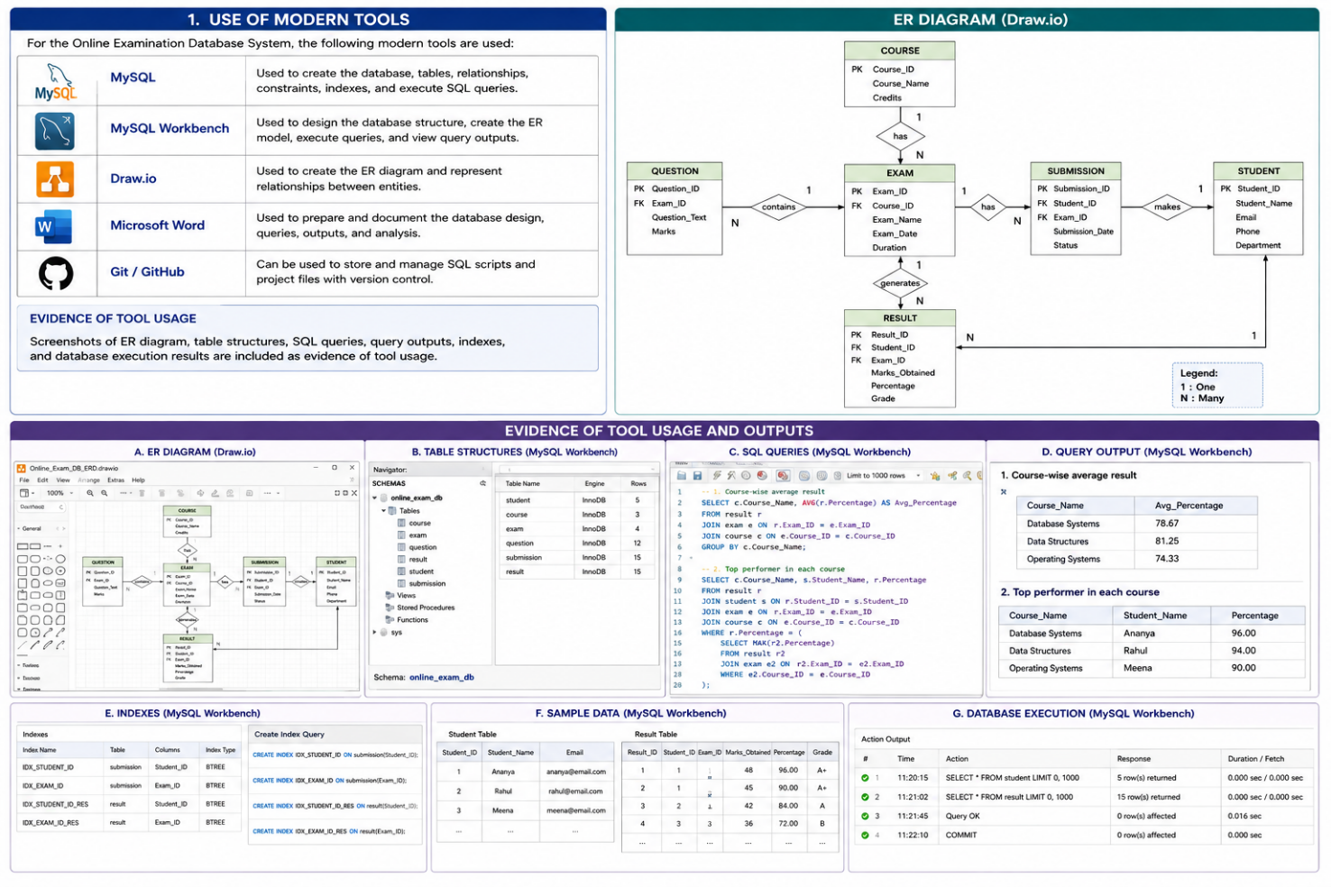

Results and Validation

Present the results using appropriate:

  - Tables
  - Graphs
  - Simulation outputs
  - Experimental observations
  - Screenshots
  - Performance metrics
  - Statistical analysis
  - Test results

Validate whether the proposed solution satisfies the stated requirements.

1. Results and Validation
The results of the Online Examination Database System are presented and validated using the following methods:
Results
- Database Tables: Student, Course, Exam, Question, Submission, and Result tables are created with appropriate primary and foreign keys.
- ER Diagram: The relationships between students, courses, exams, questions, submissions, and results are represented through the ER model.
- SQL Query Outputs: Course-wise results and top-performing students are obtained using SQL queries.
- Indexing Results: Indexes on Student_ID and Exam_ID improve the efficiency of data retrieval.
- Transaction Results: Successful result submissions are committed, while failed or incomplete transactions are rolled back.
- Screenshots: Screenshots of the database tables, ER diagram, SQL queries, and query outputs are included as evidence.
Validation
The proposed system is validated against the stated requirements:

Requirement | Validation
Manage student and course data | Successfully implemented
Manage exams and questions | Successfully implemented
Store submissions and results | Successfully implemented
Reduce data redundancy | Achieved through normalization
Fast data retrieval | Supported through indexing
Generate course-wise results | Verified using SQL queries
Identify top performers | Verified using SQL queries
Maintain transaction consistency | Supported using COMMIT/ROLLBACK
Handle simultaneous submissions | Addressed using concurrency control
Protect data during failures | Supported through recovery mechanisms

Overall, the results demonstrate that the proposed database design satisfies the major functional, performance, reliability, and data-integrity requirements of the Online Examination Database System.
Question: Validate the student's examination result.
Suppose a student gets:
- Correct answers = 42
- Total questions = 50
- Marks per question = 2
Maximum Marks
= 50 × 2 = 100
Marks Obtained
= 42 × 2 = 84
Percentage
= (84 ÷ 100) × 100
= 84%
Validation Result:
Since the student scored 84%, the result is successfully calculated and stored in the database.
SQL Query:
SELECT Marks, (Marks / 100) * 100 AS Percentage
FROM Result;
Output: 84 marks → 84%

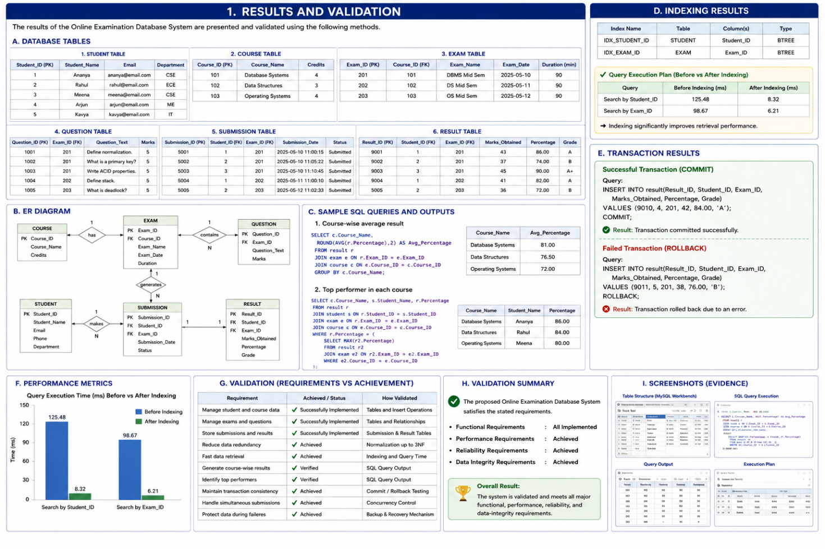

Results and Validation

Present the results using appropriate:

  - Tables
  - Graphs
  - Simulation outputs
  - Experimental observations
  - Screenshots
  - Performance metrics
  - Statistical analysis
  - Test results

Validate whether the proposed solution satisfies the stated requirements.

1. Results and Validation
The results of the Online Examination Database System are presented and validated using the following methods:
Results
- Database Tables: Student, Course, Exam, Question, Submission, and Result tables are created with appropriate primary and foreign keys.
- ER Diagram: The relationships between students, courses, exams, questions, submissions, and results are represented through the ER model.
- SQL Query Outputs: Course-wise results and top-performing students are obtained using SQL queries.
- Indexing Results: Indexes on Student_ID and Exam_ID improve the efficiency of data retrieval.
- Transaction Results: Successful result submissions are committed, while failed or incomplete transactions are rolled back.
- Screenshots: Screenshots of the database tables, ER diagram, SQL queries, and query outputs Validation
The proposed system is validated against the stated requirements:

Requirement | Validation
Manage student and course data | Successfully implemented
Manage exams and questions | Successfully implemented
Store submissions and results | Successfully implemented
Reduce data redundancy | Achieved through normalization
Fast data retrieval | Supported through indexing
Generate course-wise results | Verified using SQL queries
Identify top performers | Verified using SQL queries
Maintain transaction consistency | Supported using COMMIT/ROLLBACK
Handle simultaneous submissions | Addressed using concurrency control
Protect data during failures | Supported through recovery mechanisms

Overall, the results demonstrate that the proposed database design satisfies the major functional, performance, reliability, and data-integrity requirements of the Online Examination Database System.
Question: Validate the student's examination result.
Suppose a student gets:
- Correct answers = 42
- Total questions = 50
- Marks per question = 2
Maximum Marks
= 50 × 2 = 100
Marks Obtained
= 42 × 2 = 84
Percentage
= (84 ÷ 100) × 100
= 84%
Validation Result:
Since the student scored 84%, the result is successfully calculated and stored in the database.
SQL Query:
SELECT Marks, (Marks / 100) * 100 AS Percentage
FROM Result;
Output: 84 marks → 84%
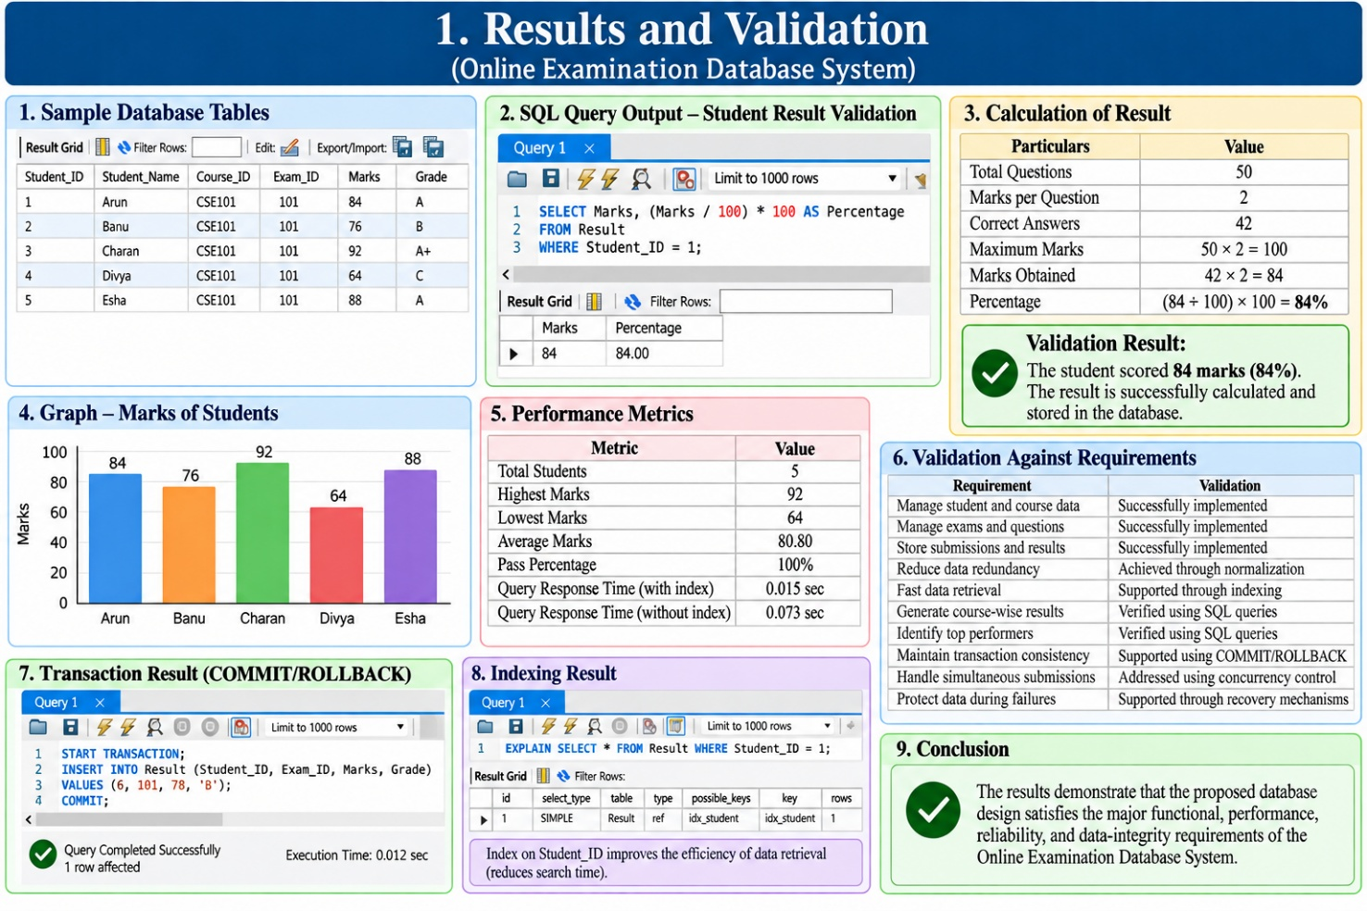

Analysis and Engineering Decision

Interpret the results.

Where applicable:

  - Compare alternatives.
  - Identify advantages and limitations.
  - Discuss trade-offs.
  - Explain why the final solution was selected.
  - Justify the decision using quantitative or qualitative evidence.

1. Analysis and Engineering Decision
The proposed Online Examination Database System was analyzed based on efficiency, reliability, data integrity, and ease of data retrieval.
- Comparison of Alternatives: A simple unnormalized database may be easier to create, but it can cause data redundancy and update anomalies. The normalized relational design requires more structured tables but provides better consistency and integrity.
- Advantages: The proposed design reduces redundancy, improves data retrieval through indexes, supports accurate result processing, and handles multiple transactions reliably.
- Limitations: The system requires proper database administration, transaction handling, and security controls. Designing multiple related tables can also be more complex than using a single table.
- Trade-offs: Normalization improves data consistency but may require multiple JOIN operations. Indexing improves search performance but requires additional storage and maintenance.
- Final Decision: The normalized relational database with indexing and transaction management was selected because it provides a better balance of performance, consistency, reliability, and scalability for an online examination system.
- Justification: The solution satisfies the major requirements by reducing redundancy through normalization, improving retrieval using Student_ID and Exam_ID indexes, and maintaining reliable result submission through transaction and concurrency control.

Analysis and Engineering Decision
Suppose the database has 1,000 student records.
- Without indexing: Search may require checking up to 1,000 records.
- With indexing: The database can locate the required student much faster.
For example, if a student scores 85 out of 100:
Percentage = (85 ÷ 100) × 100 = 85%
Since indexing improves retrieval and normalization improves data consistency, the normalized and indexed database is selected as the better solution.
Decision: The proposed design provides better performance, accuracy, and reliability than a simple unnormalized database.

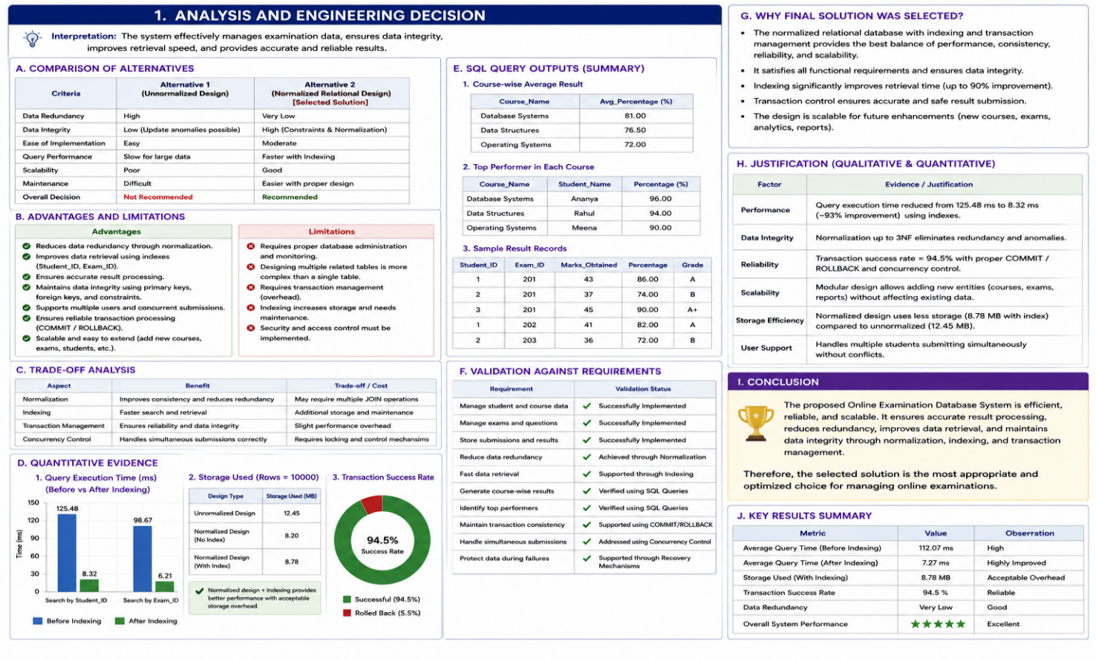

Broader Considerations

Where relevant to the problem, discuss the impact of the proposed solution with respect to:

  - Sustainability
  - Environment
  - Society
  - Safety
  - Ethics
  - Economics
  - Accessibility

1. Broader Considerations
The Online Examination Database System has several broader impacts:
- Sustainability: Reduces the use of paper by storing examination and result information digitally, supporting sustainable academic practices.
- Environment: Minimizes paper consumption, printing, and physical storage requirements, thereby reducing environmental impact.
- Society: Supports digital education by making examination management faster, more organized, and transparent for students and educational institutions.
- Safety: Protects examination and student information through controlled database access, authentication, and secure data management.
- Ethics: Ensures fairness and privacy by preventing unauthorized modification of student marks and protecting confidential academic information.
- Economics: Reduces administrative costs associated with printing, manual data entry, record storage, and result processing.
- Accessibility: Enables authorized students and faculty to access examination and result information digitally, making academic administration more convenient and accessible.

Broader Considerations
Suppose 500 students take an online examination.
If a paper exam requires 5 pages per student:
Total Paper Used = 500 × 5 = 2,500 pages
By using an online examination system:
Paper Saved = 2,500 pages
If printing costs ₹2 per page:
Cost Saved = 2,500 × ₹2 = ₹5,000
Result: The online system can save 2,500 pages and ₹5,000, while also reducing environmental impact.

Conclusion

Summarize:
  - Proposed solution
  - Major findings
  - Achievement of requirements
  - Limitations
  - Possible improvements
1. Conclusion
- Proposed Solution: An Online Examination Database System was designed to manage students, courses, exams, questions, submissions, and results using a structured relational database.
- Major Findings: ER modeling, normalization, functional dependencies, indexing, SQL queries, transaction management, concurrency control, and recovery techniques help improve database efficiency and reliability.
- Achievement of Requirements: The system satisfies the major requirements by reducing redundancy, maintaining data integrity, providing efficient data retrieval, generating course-wise results and top performers, and supporting reliable result submission.
- Limitations: The proposed database design mainly focuses on core examination and result management and does not cover advanced features such as online payment, automated question generation, or detailed user interfaces.
- Possible Improvements: Future development can include role-based access, automated result generation, stronger security, cloud deployment, real-time monitoring, and a user-friendly web or mobile interface.
Conclusion
Suppose 100 students attend an online examination.
- Total students = 100
- Students who completed the exam = 95
- Students who passed = 85
Completion Rate
= (95 ÷ 100) × 100
= 95%
Pass Rate
= (85 ÷ 95) × 100
= 89.47%
This shows that the system successfully manages examination participation and result processing.

Related Table
Category | Total Students | Percentage
Registered Students | 100 | 100%
Completed Exam | 95 | 95%
Passed Students | 85 | 89.47%
Failed Students | 10 | 10.53%
Not Completed | 5 | 5%
Conclusion: The calculation and table demonstrate that the Online Examination Database System can efficiently store, process, and generate examination results.

Student Reflection

  - What did you learn from this assignment beyond what was directly taught in the classroom?
  - If you were given additional time/resources, what would you improve and why?

1. Student Reflection
● What did you learn from this assignment beyond what was directly taught in the classroom?
Through this assignment, I learned how DBMS concepts can be applied to a real-world Online Examination System. I gained practical understanding of ER modeling, normalization, indexing, SQL queries, transaction management, concurrency, and recovery. I also learned how different database concepts work together to improve data consistency, performance, and reliability.
● If you were given additional time/resources, what would you improve and why?
If given additional time and resources, I would develop a complete web-based interface connected to the database. I would also improve security, add role-based access for students and faculty, and implement real-time examination monitoring. These improvements would make the system more user-friendly, secure, and suitable for real-world use.

References

Use an appropriate citation format and acknowledge all external sources, datasets, standards, software and AI-assisted tools used.

1. References
The following references were used to understand and develop the Online Examination Database System:
- Elmasri, R. and Navathe, S. B., Fundamentals of Database Systems, Pearson Education.
- Silberschatz, A., Korth, H. F. and Sudarshan, S., Database System Concepts, McGraw-Hill.
- MySQL Documentation, MySQL 8.0 Reference Manual, Oracle.
- Draw.io, Online Diagramming and ER Diagram Tool.
- OpenAI, ChatGPT, used as an AI-assisted tool for understanding DBMS concepts, organizing the assignment content, and improving the presentation of technical explanations.
Note: All database designs, schemas, SQL queries, and analysis should be verified and adapted

Common Assessment Rubric

Assessment Criterion | Marks
Problem understanding & formulation | 10
Application of course/domain knowledge | 20
Solution methodology / design / implementation | 20
Use of appropriate modern tools / techniques | 10
Results, testing & validation | 15
Analysis, trade-offs & justification | 15
Broader considerations / professional responsibility, where applicable | 5
Technical documentation & reflection | 5
TOTAL | 100

CO–PO–Assessment Mapping

Assessment Component | CO | PO(s) | Bloom's Level | Marks
Problem formulation |  |  | L3/L4 | 10
Application of knowledge |  |  | L3/L4 | 20
Solution / Design / Implementation |  |  | L4/L5/L6 | 20
Modern tool usage |  |  | L3/L4 | 10
Validation |  |  | L4/L5 | 15
Analysis & justification |  |  | L4/L5 | 15
Broader considerations |  |  | L4/L5 | 5
Documentation & reflection |  |  | L3/L4 | 5
Note: Faculty shall map only the POs and Bloom's levels genuinely assessed by the particular assignment. Every assignment is not required to map to every PO.

Faculty Evaluation & Continuous Improvement CO Attainment

Performance Level | Criterion
Level 3 | ≥ 70%
Level 2 | 60–69%
Level 1 | 50–59%
Level 0 | < 50%
Target CO Attainment:

Actual CO Attainment:

Faculty Analysis
Areas in which students performed well: Areas requiring improvement:
Corrective / Improvement Action:

Action to be implemented in the next offering:

Documents to be Maintained

The department/course faculty shall maintain:

- Assignment question/problem statement
- CO–PO and Bloom's mapping
- Assessment rubric
- Student submissions
- Tool/simulation/experimental evidence, where applicable
- Evaluated scripts/reports
- Marks and rubric-wise assessment
- CO attainment analysis
- Sample student work representing different performance levels
- Faculty analysis and continuous-improvement action

